Darshana pubudu keerthirathna

ICM 106 OR23106564

Database Management System – Week 01 assignment

**01.**

CREATE DATABASE university;

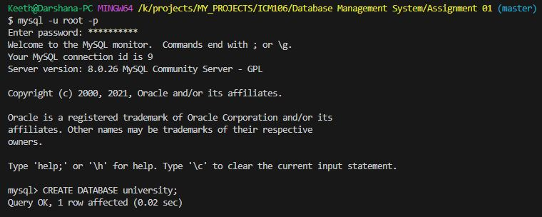use university;

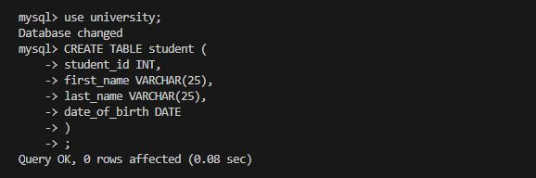

**02.**

CREATE TABLE student (

student_id INT,

first_name VARCHAR(25),

last_name VARCHAR(25),

date_of_birth DATE

);

INSERT INTO student (student_id,first_name,last_name,date_of_birth)

VALUES

(1,'John','Doe','1990-05-15'),

(2,'Jane','Smith','1992-08-22'),

(3,'Bob','Johnson','1995-02-10')

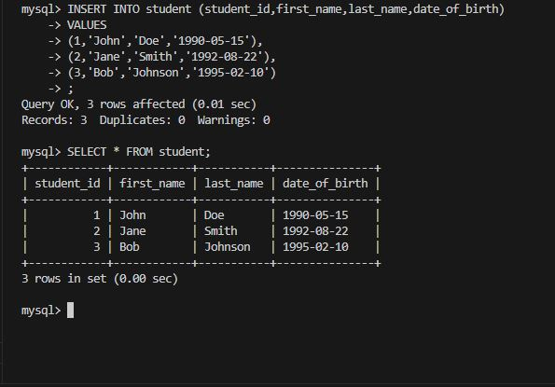 ;

**03.**

CREATE TABLE book(

book_id INT,

title VARCHAR(30),

author VARCHAR(30),

publication_year INT

);

INSERT INTO book (book_id,title,author,publication_year)

VALUES

(1,'The Great Gatsby','F. Scott Fitzgerald',1925),

(2,'To Kill a Mockingbird', 'harper Lee',1960),

(3,'1984','George Orwell',1949)

;

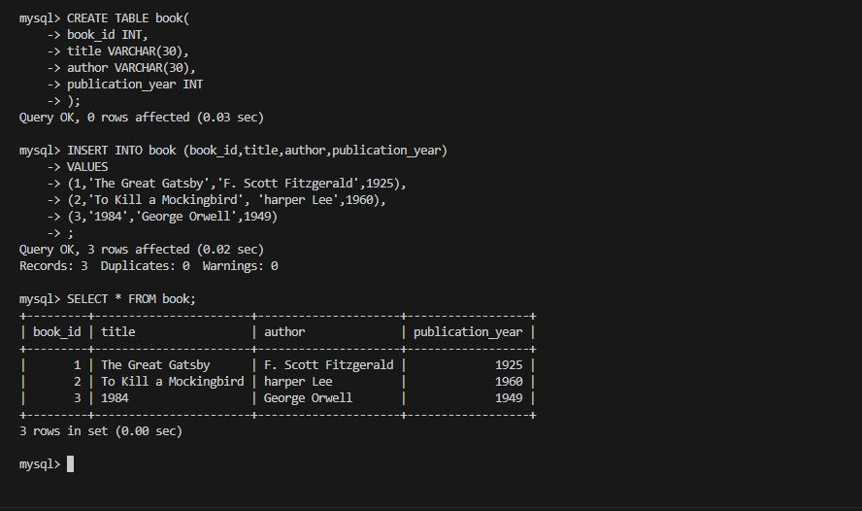

**04.**

CREATE TABLE orders(

order_id INT,

customer_id INT,

order_date DATE,

total_amount DECIMAL

);

INSERT INTO orders(order_id,customer_id,order_date,total_amount)

VALUES

(1,101,'2023-01-15',150.75),

(2,102,'2023-02-20',75.50),

(3,103,'2023-03-10',200.25)

;

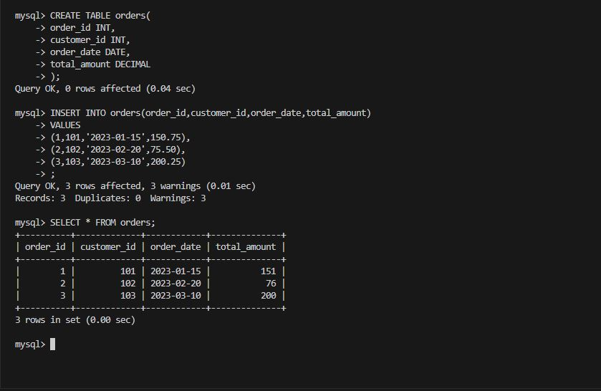

**05.**

CREATE TABLE employee(

employee_id INT,

first_name VARCHAR(20),

last_name VARCHAR(20),

department_id INT

);

INSERT INTO employee (employee_id,first_name,last_name,department_id)

VALUES

(1,'Alice','Johnson',101),

(2,'Bob','Smith',102),

(3,'Charlie','Brown',103)

;

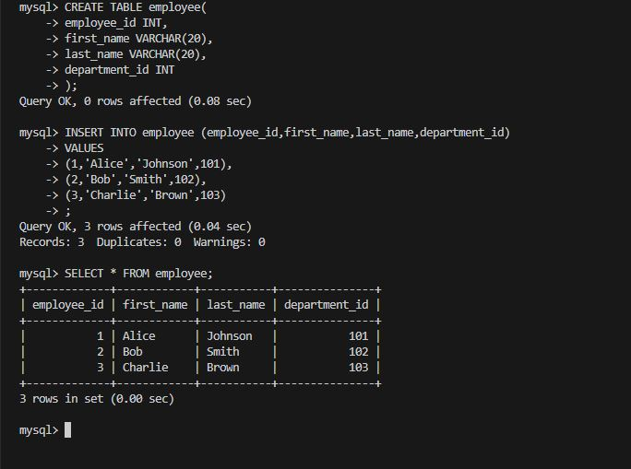

**06.**

CREATE TABLE product(

product_id INT,

product_name VARCHAR(20),

price DECIMAL,

stock_quantity INT

);

INSERT INTO product(product_id,product_name,price,stock_quantity)

VALUES

(1,'Laptop',899.99,50),

(2,'Smartphone',499.99,100),

(3,'Headphone',79.99,200)

;

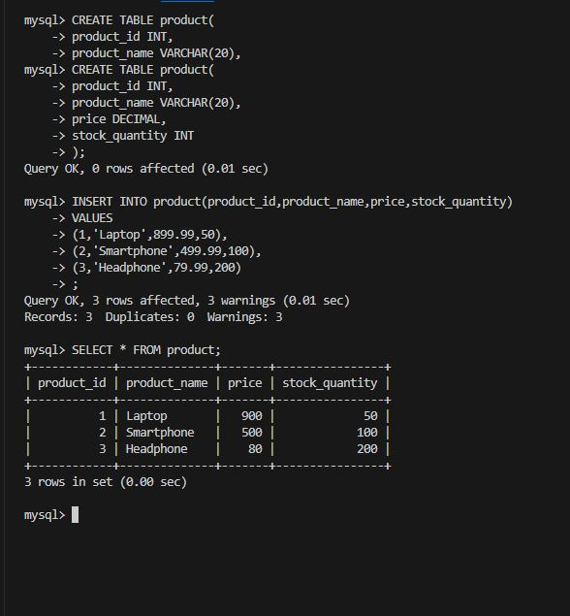

**07.**

CREATE TABLE category(

category_id INT,

category_name VARCHAR(20)

);

INSERT INTO category(category_id,category_name)

VALUES

(1,'Electronic'),

(2,'Books'),

(3,'Clothing')

;

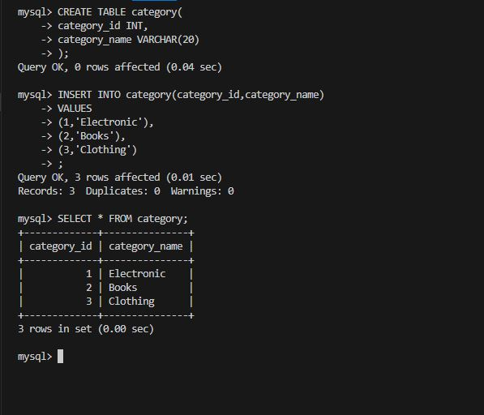

**08.**

CREATE TABLE invoice(

invoice_id INT,

customer_id INT,

invoice_date DATE,

total_amount DECIMAL

);

INSERT INTO invoice(invoice_id,customer_id,invoice_date,total_amount)

VALUES

(1,201,'2023-04-05',120.50),

(2,202,'2023-05-12',75.25),

(3,203,'2023-06-20',300.00)

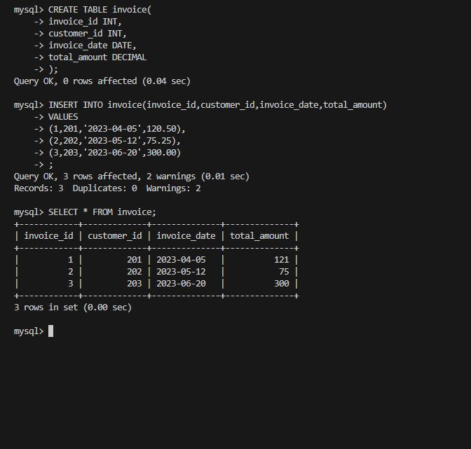;

**09.**

CREATE TABLE event(

event_id INT,

event_name VARCHAR(30),

date DATE,

location VARCHAR(30)

);

INSERT INTO event(event_id,event_name,date,location)

VALUES

(1,'Conference X','2023-07-15','City Hall'),

(2,'Musical Festival','2023-08-22','Park Plaza'),

(3,'Tech Expo','2023-09-10','Convention Center')

;

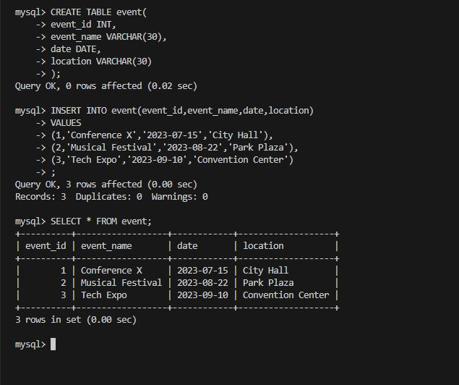

**10.**

CREATE TABLE task(

task_id INT,

task_description VARCHAR(40),

due_date DATE

);

INSERT INTO task(task_id,task_description,due_date)

VALUES

(1,'Complete project proposal','2023-10-15'),

(2,'Prepare for meeting with client','2023-11-02'),

(3,'Review and submit report','2023-12-01')

;

